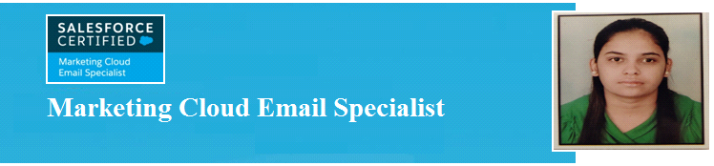

Name – Priyanka Singh
Email – singh.priyankacloud@gmail.com
Mobile – 9873413989
Address – Bulandshahr, UP

GENERAL PROFILE
Salesforce Marketing Cloud Specialist and a result-oriented professional with 8.6 years of experience working with various companies on multiple technologies like Salesforce Marketing Cloud, Marketo, ON24, and Digital Marketing. Certified as an Email Marketing Cloud Specialist (SFMC). Successfully created and implemented marketing campaigns through e-marketing tools and technologies. Currently working as Senior Application Developer in Telus International.

My strengths include exceptional time management, ability to multitask, and willingness to assist my team at all times.

PROFESSIONAL EXPERIENCE:
Telus International  January/2022 - Present | Responsibilities:  - Creating emails by inserting text, images, and HTML links into pre-existing templates in the email studio.  - Monitoring the performance, effectiveness, and accuracy of all outbound emails.  - Building Journeys, Automation Processes in Salesforce Marketing Cloud (exact target).  - Worked on designing campaigns for emails like scheduled and user-initiated and A/B Testing.  - Develop audience data extensions for campaigns based on guidance from stakeholders.
HCL Technologies  March/2020 - January/2022  Salesforce Marketing Specialist | Responsibilities:  - Designing and implementing email campaign templates in addition to data collection and analytics for tracking campaigns.  - Worked on designing campaigns for emails like scheduled and user-initiated and A/B Testing.  - Create import activities, email activities, and other activities using Automation Studio in Exact target Marketing Cloud.  - Helped in designing Data Extensions & Filtered Data Extensions along with Data Extracts in Exact target Marketing Cloud.  - Leading the team and providing training to team members and resolving queries for the entire team.
CyFuture India Pvt Ltd  October/2016 - February/2020  Automation Marketing Analyst | Responsibilities:  - Events setup on ON24 and sync it with Marketo.  - Designing of pages for digital events and webinars.  - Email Customization and scheduling as per client requirement.  - Share report to the client for the conducted event through Marketo.
Bhanu Infrastructure Pvt Ltd  July/2014 - September/2016  Digital Marketing Analyst | Responsibilities:  - Implementing Search Marketing strategies including SEO, SEM and Internet Marketing strategies.  - Researching the best keywords using tools such as Google Ad words, with less competition and high search volume for high Ranking of website.  - On-page and oﬀ page optimization (SEO), Social Media Optimizing (SMO) (Facebook, Twitter, Google Plus, LinkedIn, YouTube etc.). Staying up to date with the latest developments in the SEO ﬁeld.
FNG Developers  December/2012 - June/2014  Backend Administration | Responsibilities:  - Following standardized company procedures relating to all aspects of Office performance.  - Manage office events, emails, and other general office activities.  - Maintaining office contracts and confidential documentation. Updating databases with confidential and relevant information.
Relevant Education & Professional Development:
Education: | - PTU University  Master of Computer Application  2010 -2012  - DAV Centenary College  Bachelor of Computer Application  2007 -2010
Certifications: | - Email Marketing Cloud Specialist  Institution Name - Salesforce
Technical Summary: | - Programming Languages  HTML  - Databases  SOQL  - Other Skills  Journey Builder, Automation Studio and Data Loader, Marketo, On24, D365, RedTiger, etc.

Declaration

I hear by that all the information is correct and true to the best of my knowledge and belief.
Date: Priyanka Singh
Place:

